Assignment -13
Joins
- Write a query to find the addresses (location_id, street_address, city, state_province, country_name) of all the departments.
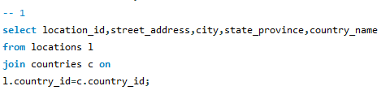
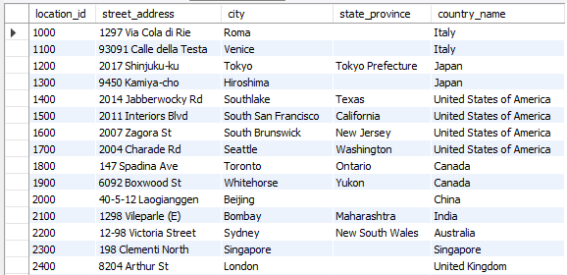
- Write a query to find the name (first_name, last_name), department ID, and name of all the employees.
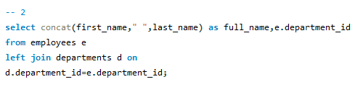
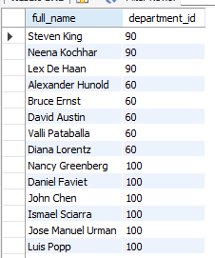
- Write a query to find the name (first_name, last_name), job, department ID and name of the employees who work in London.
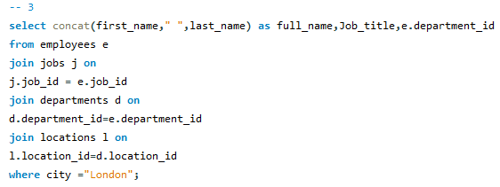
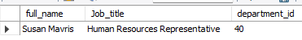
- Write a query to find the employee id, name (last_name), along with their manager ID and name (last_name).
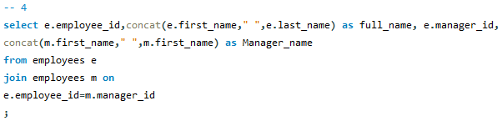
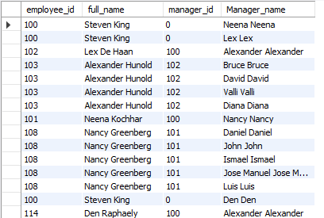
- Write a query to find the name (first_name, last_name) and hire date of the employees who were hired after 'Jones.
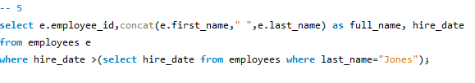
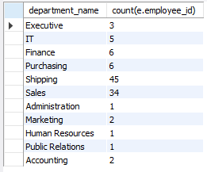
- Write a query to get the department name and the number of employees in the department.
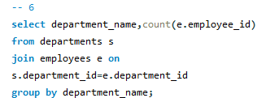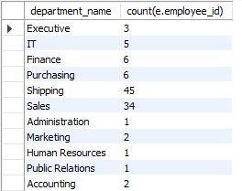
- Write a query to find the employee ID, job title, and number of days between the ending date and starting date for all jobs in department 90.
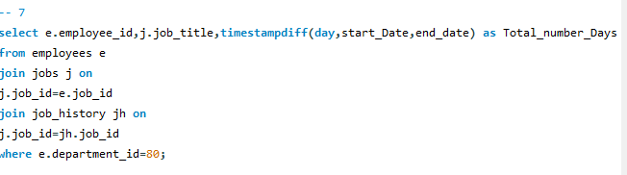
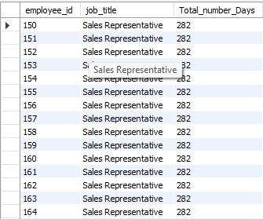
- Write a query to display the department ID and name, and the first name of the manager.
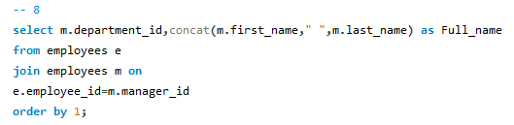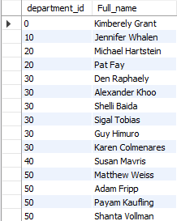
- Write a query to display the department name, manager name, and city.
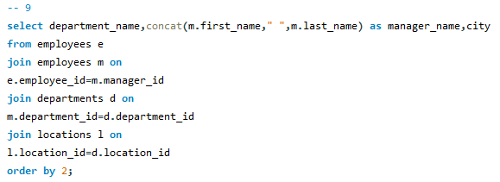
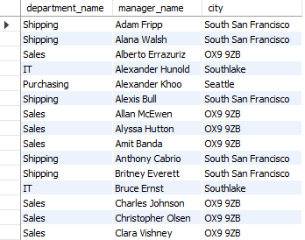
- Write a query to display the job title and average salary of employees.
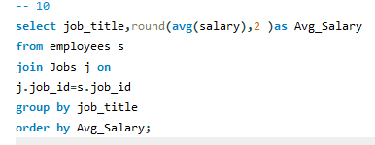
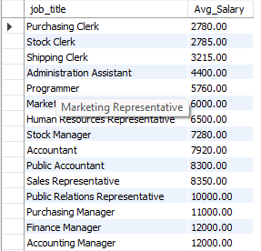
- Write a query to display job title, employee name, and the difference between the employee's salary and the minimum salary for the job.
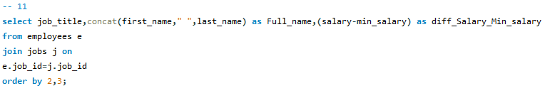
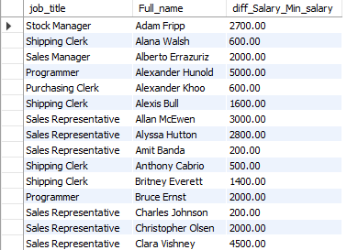
- Write a query to display the job history that was done by any employee who is currently drawing a salary of more than 10000 of salary.
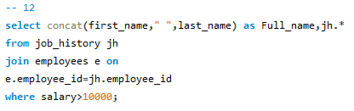
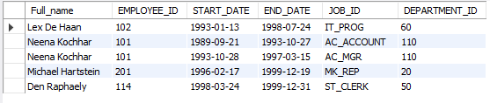
- Write a query to display department name, name (first_name, last_name), hire date, and salary of the manager for all managers whose experience is more than 15 years.
